**Table of Contents**

**1. Login Screen** 4

**1.1 Forgot Password Screens** 5

**2. SignUp Page** 6

**2.1 SignUp Validations Screens** 7

**2.2 User Registration Confirmation Message Box and Email.** 8

**3.Main Menu** 9

**3.1 Customers Order History** 10

**3.2 Customer Account Information Edit and Update in DATABASE** 11

**4. Vegetarian Menu** 12

**5. Non-Vegetarian Menu** 13

**6. Beverages & Sides Menu** 14

**7. Cart** 15

**8.Receipt And Order Confirmation Mail** 16

**9. Employee Main Screen** 17

**9.1 Customer Details Edit And Update In Database** 18

**10. Employee New Order Screens** 19

**11. Order Status** 20

**11.1 Pending** 20

**11.2 Preparing** 21

**11.3 Ready** 22

**11.4 Cancelled** 23

**12. Reports** 24

**12.1 Customers Table** 24

**12.2 Sales Table** 25

**12.3 Dashboard** 26

# **1. Login Screen**

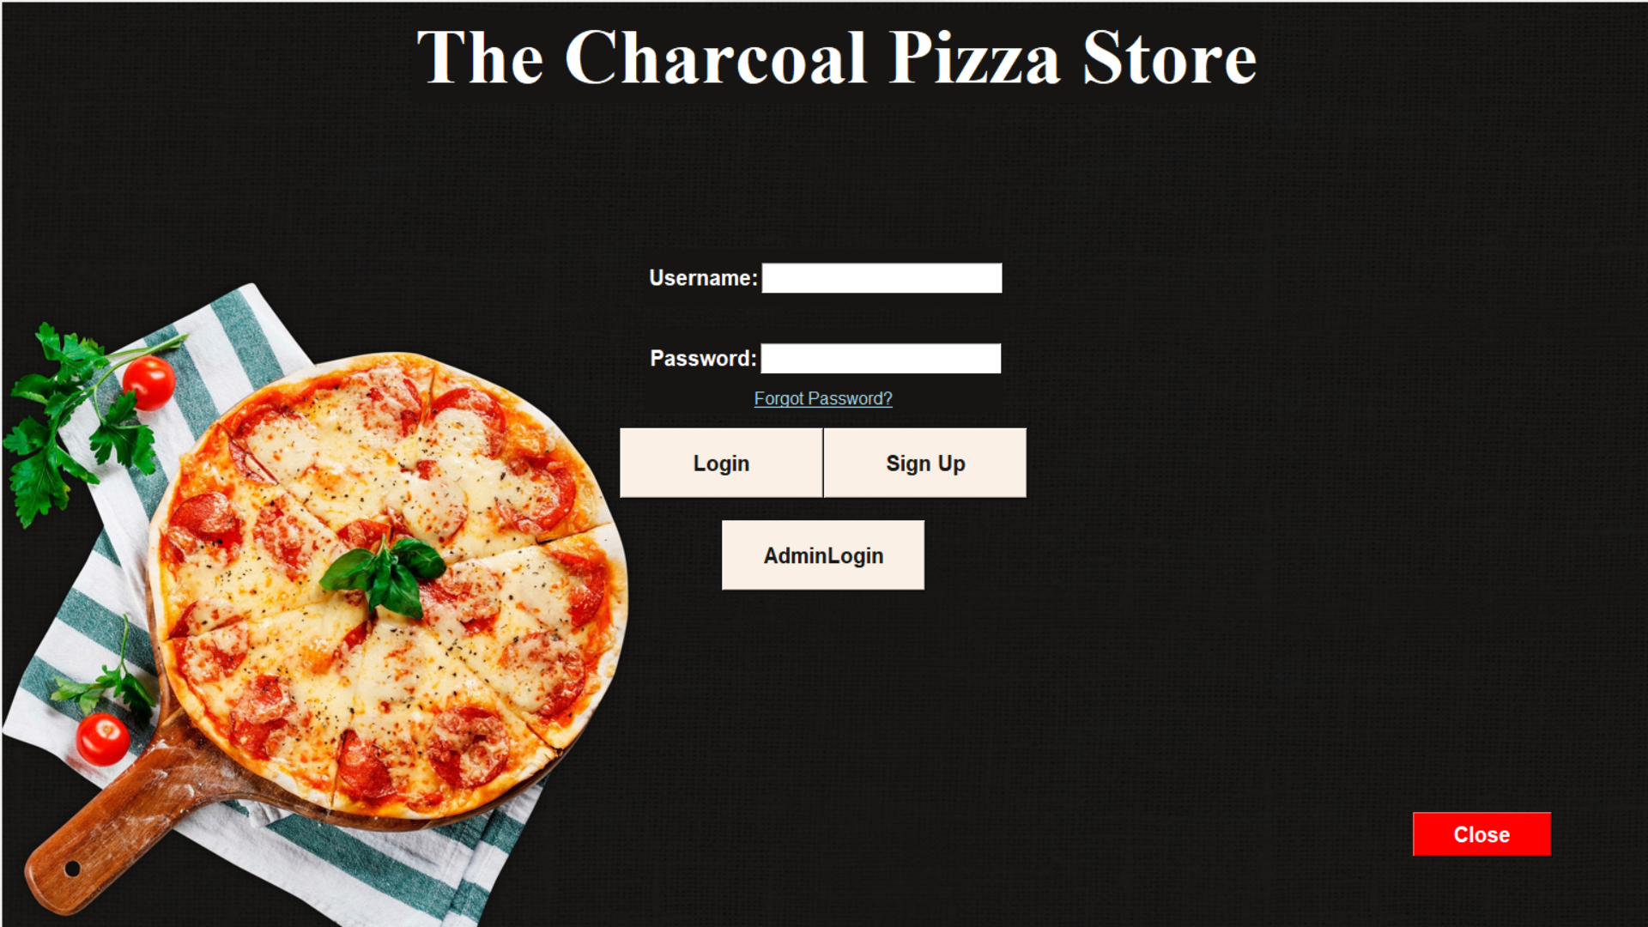

## **1.1 Forgot Password Screens**

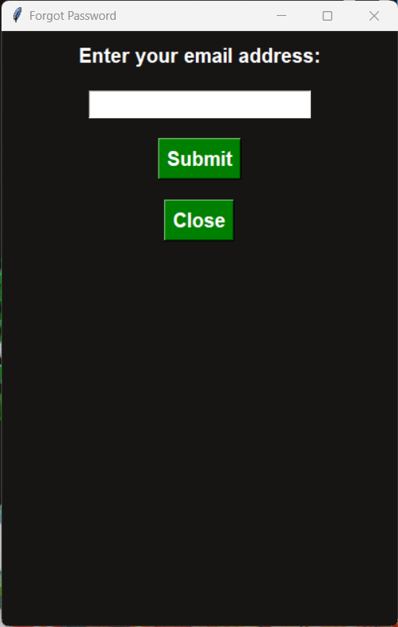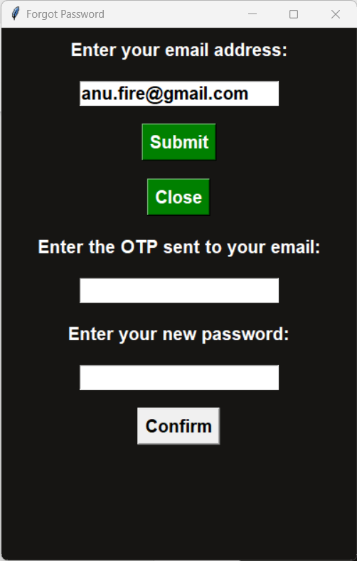

# **2. SignUp Page**

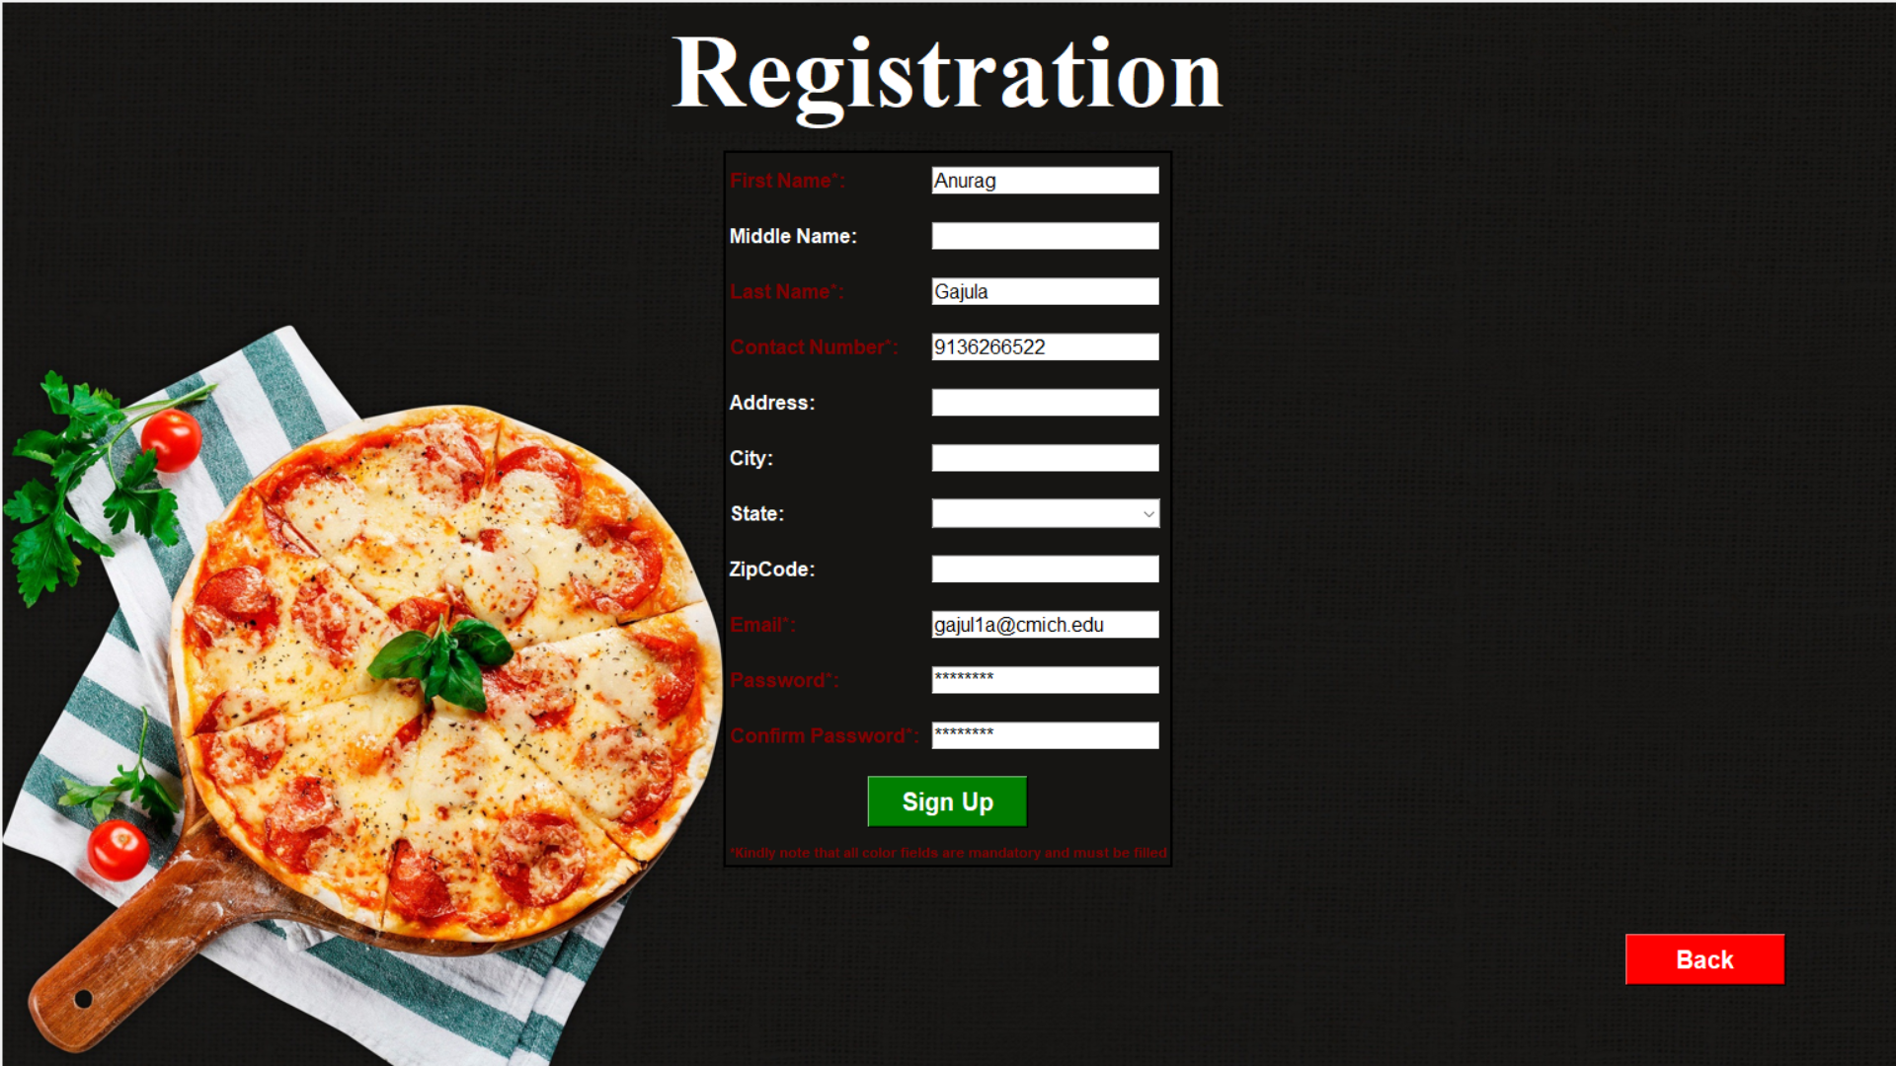

## **2.1 SignUp Validations Screens**

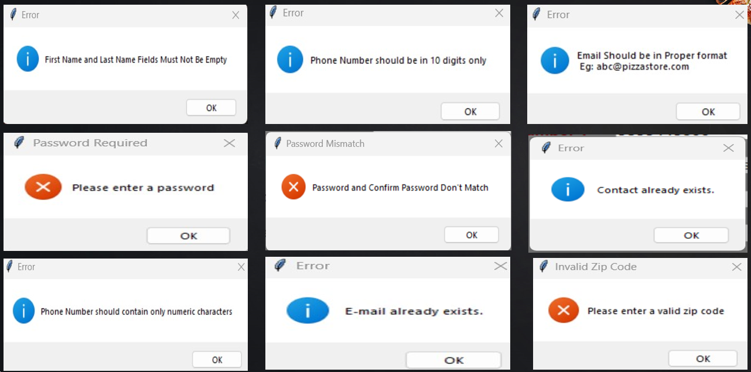

## **2.2 User Registration Confirmation Message Box and Email.**

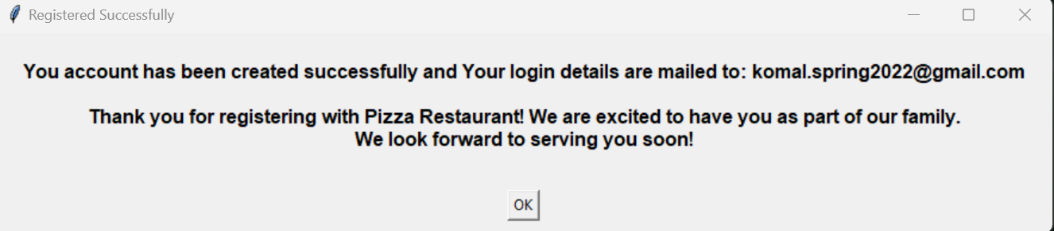

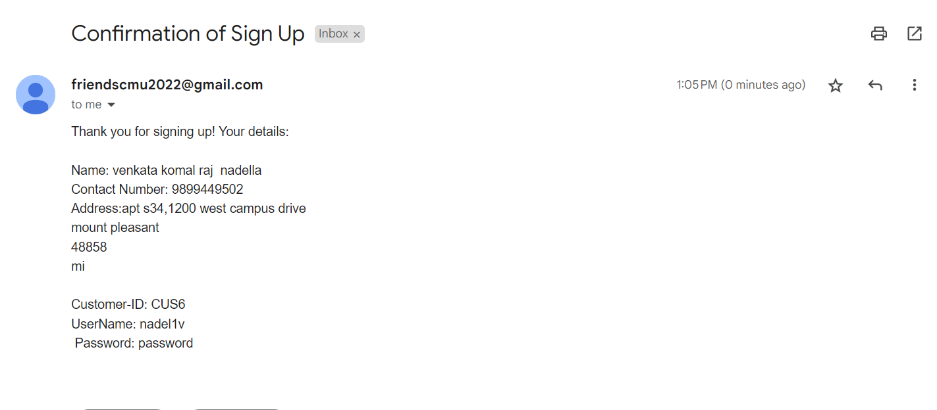

# **3.Main Menu**

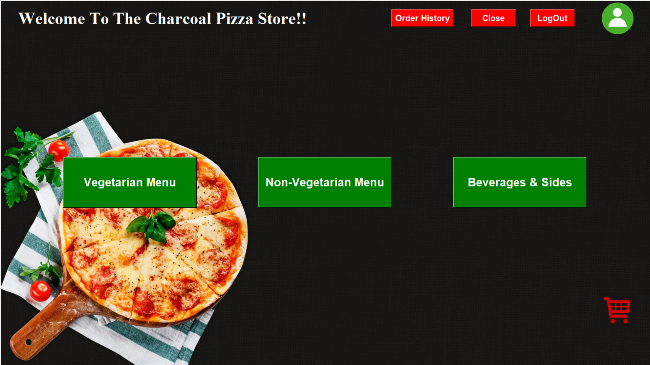

## **3.1 Customers Order History**

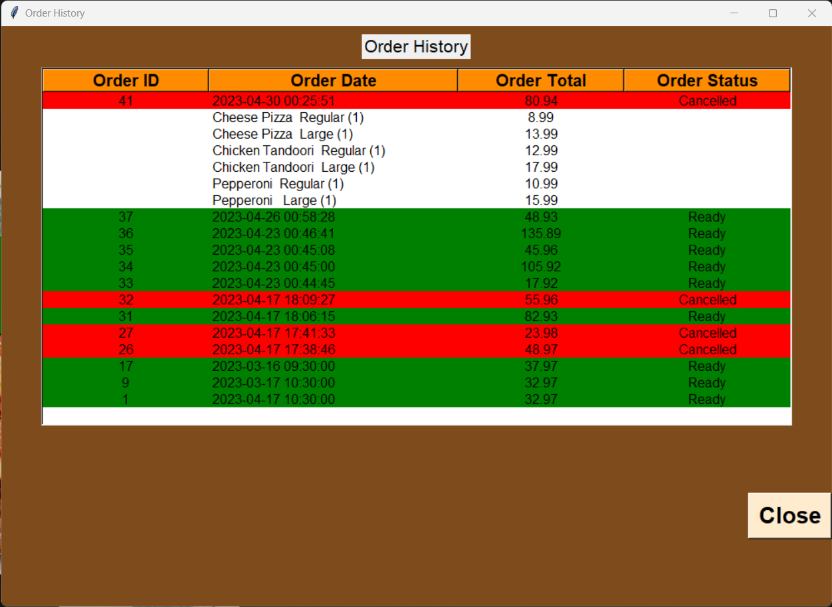

## **3.2 Customer Account Information Edit and Update in DATABASE**

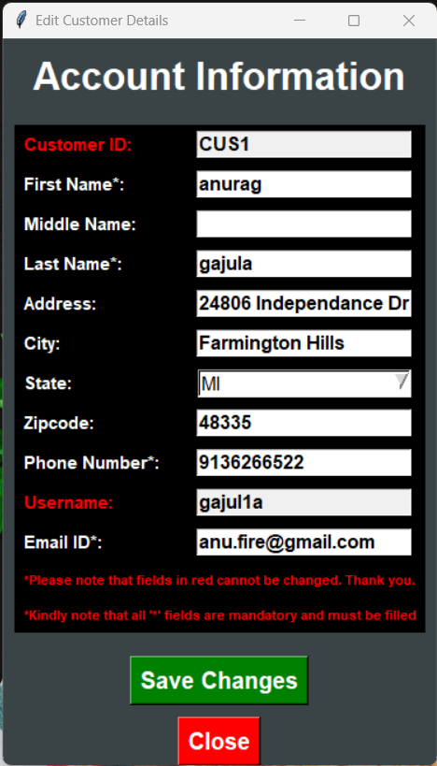

# **4. Vegetarian Menu**

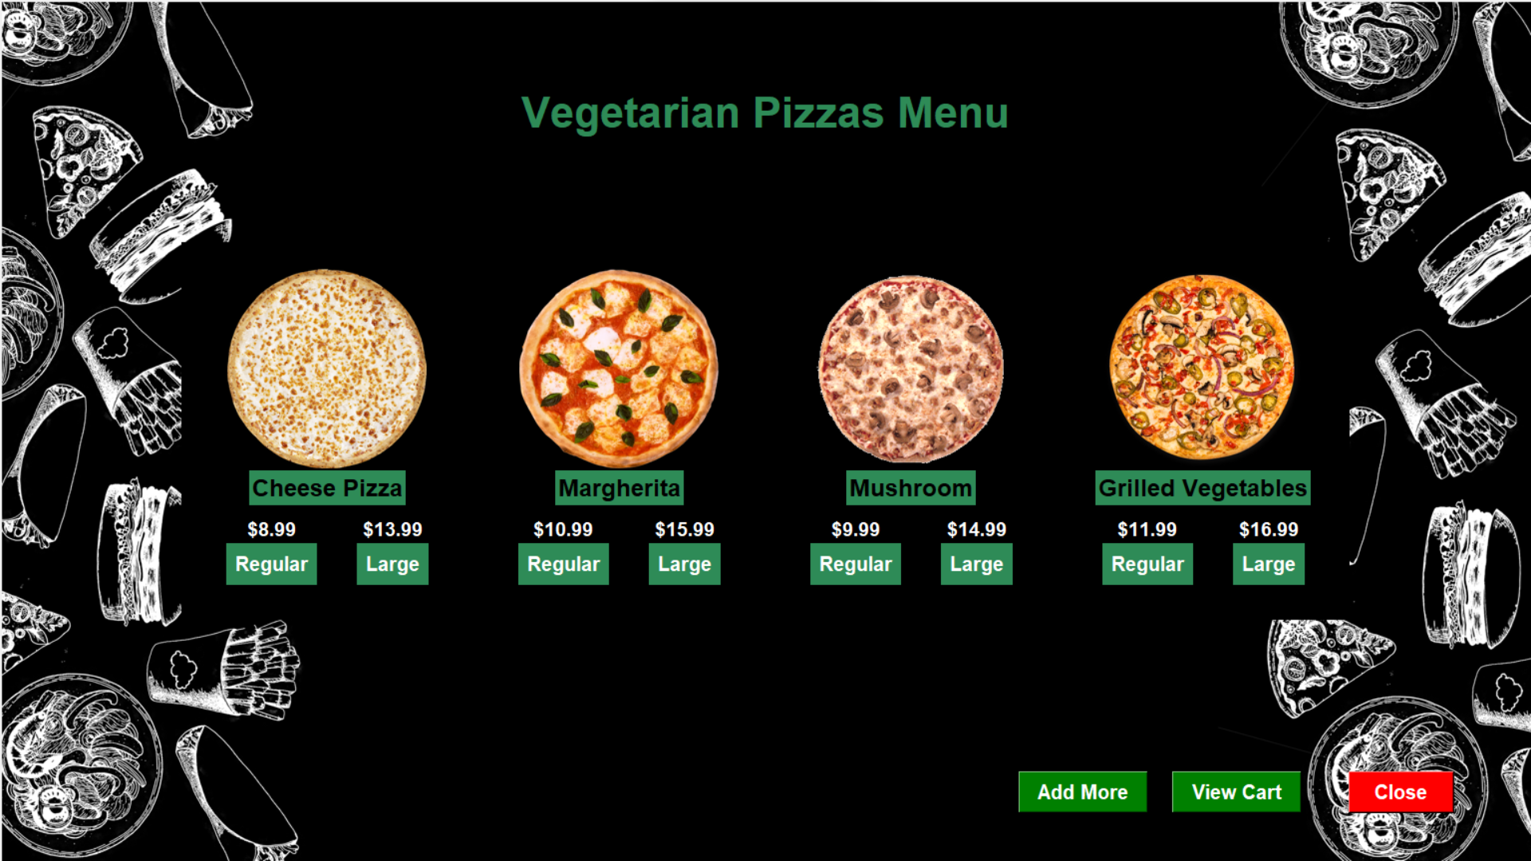

# **5. Non-Vegetarian Menu**

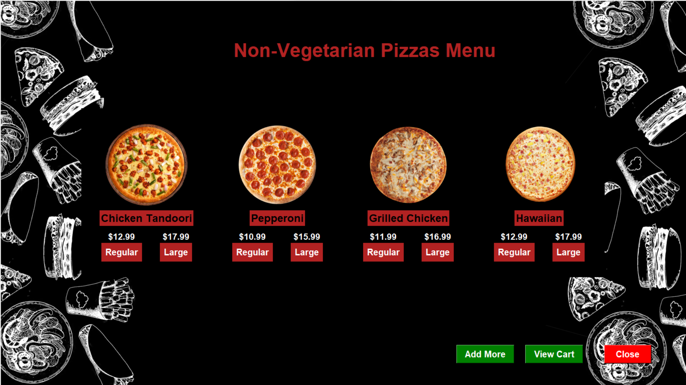

# **6. Beverages & Sides Menu**

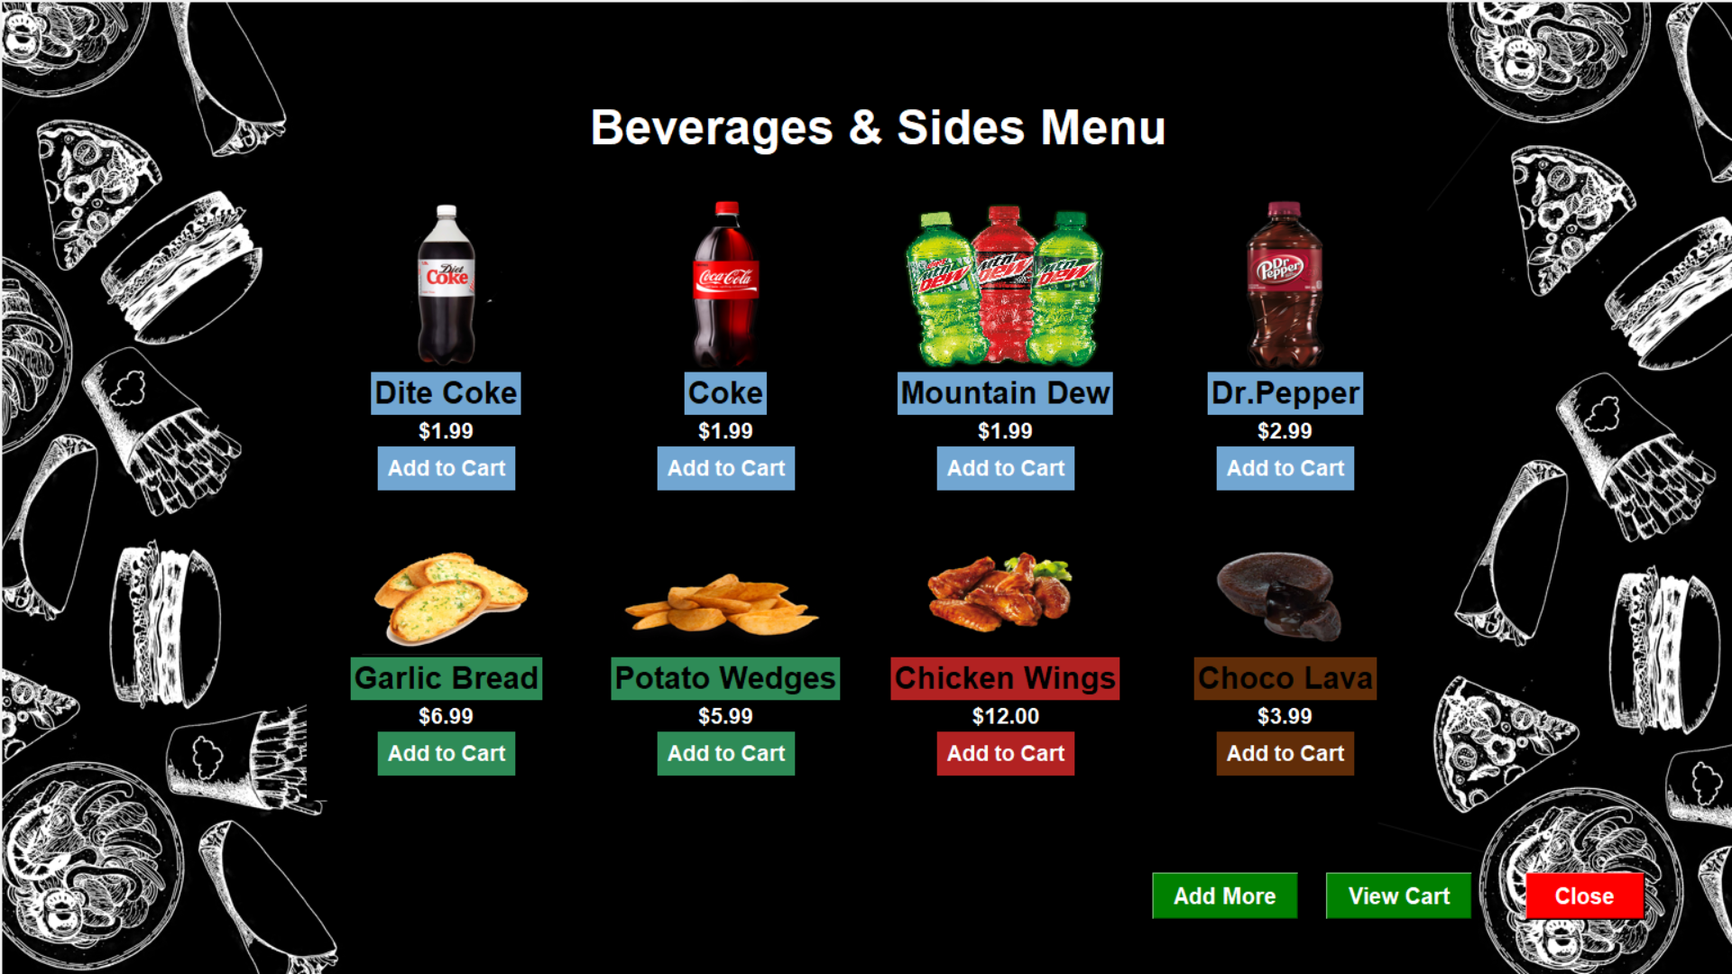

# **7. Cart**

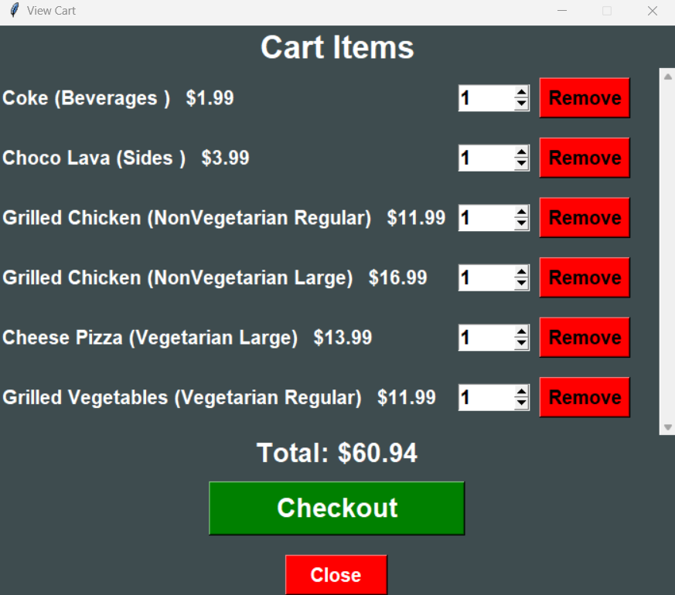

# **8.Receipt And Order Confirmation Mail**

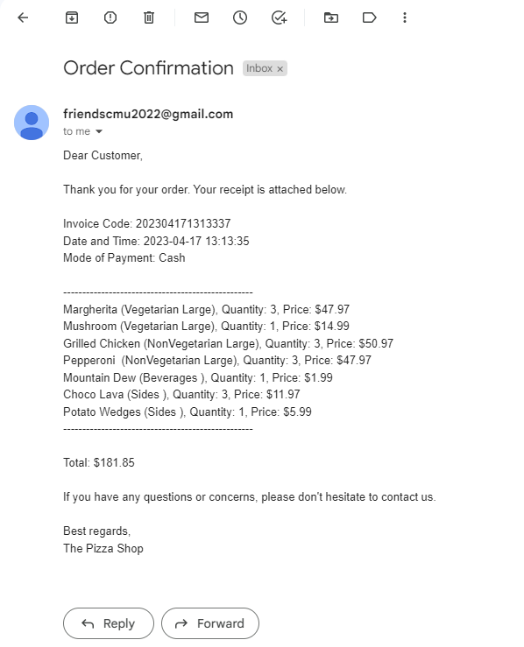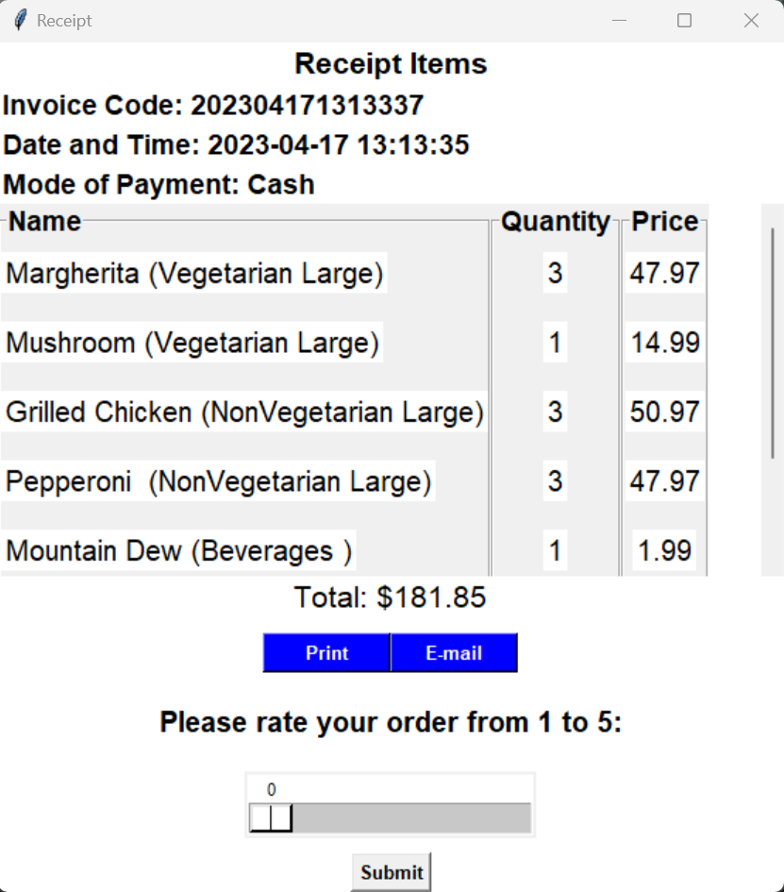

# **9. Employee Main Screen**

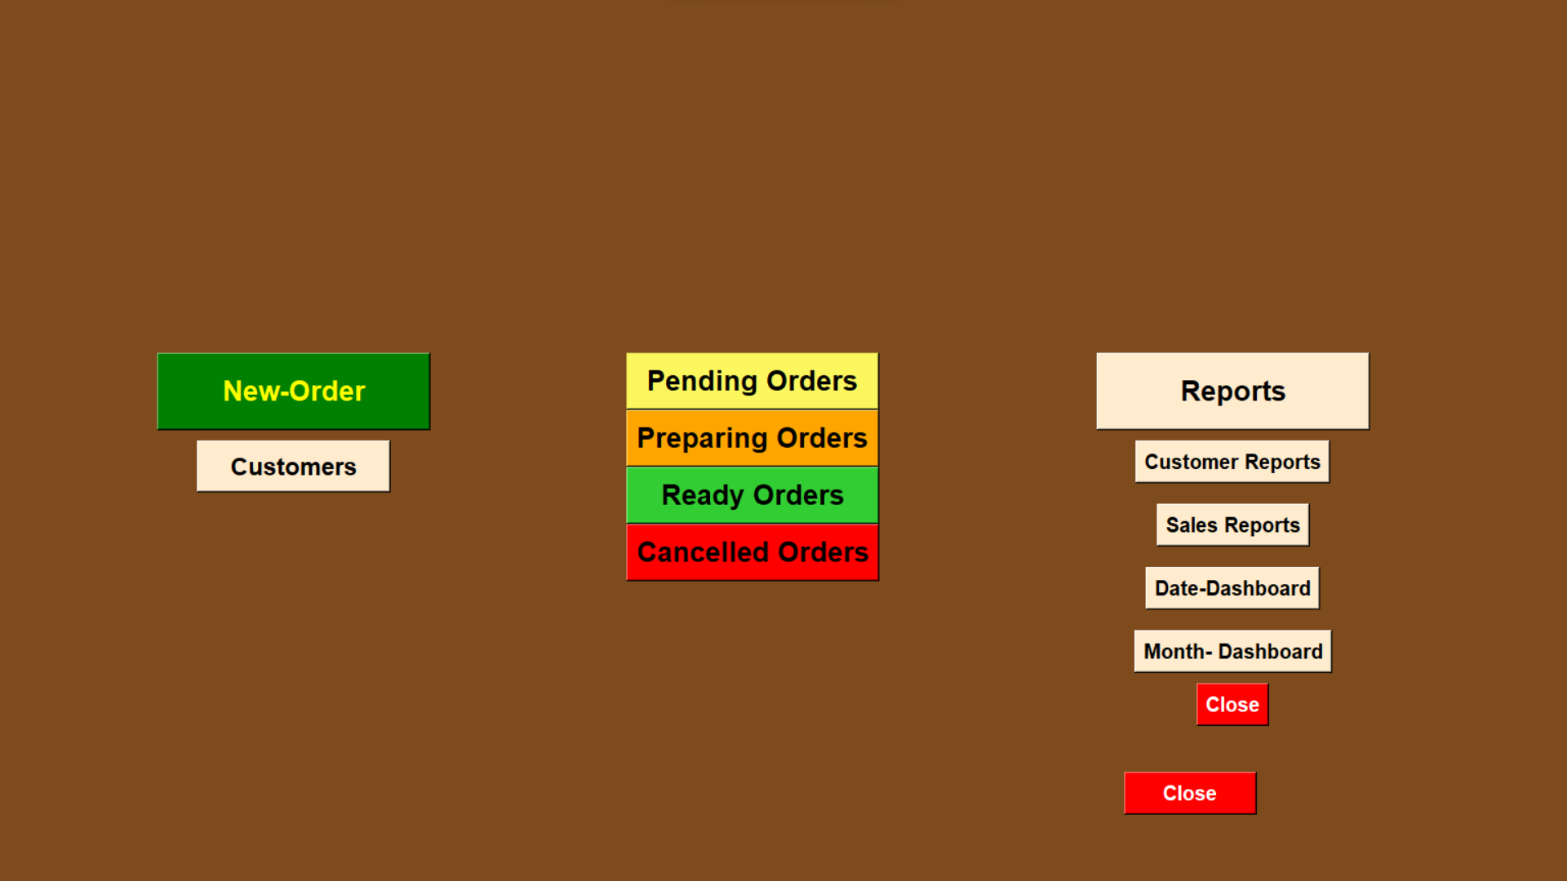

## **9.1 Customer Details Edit And Update In Database**

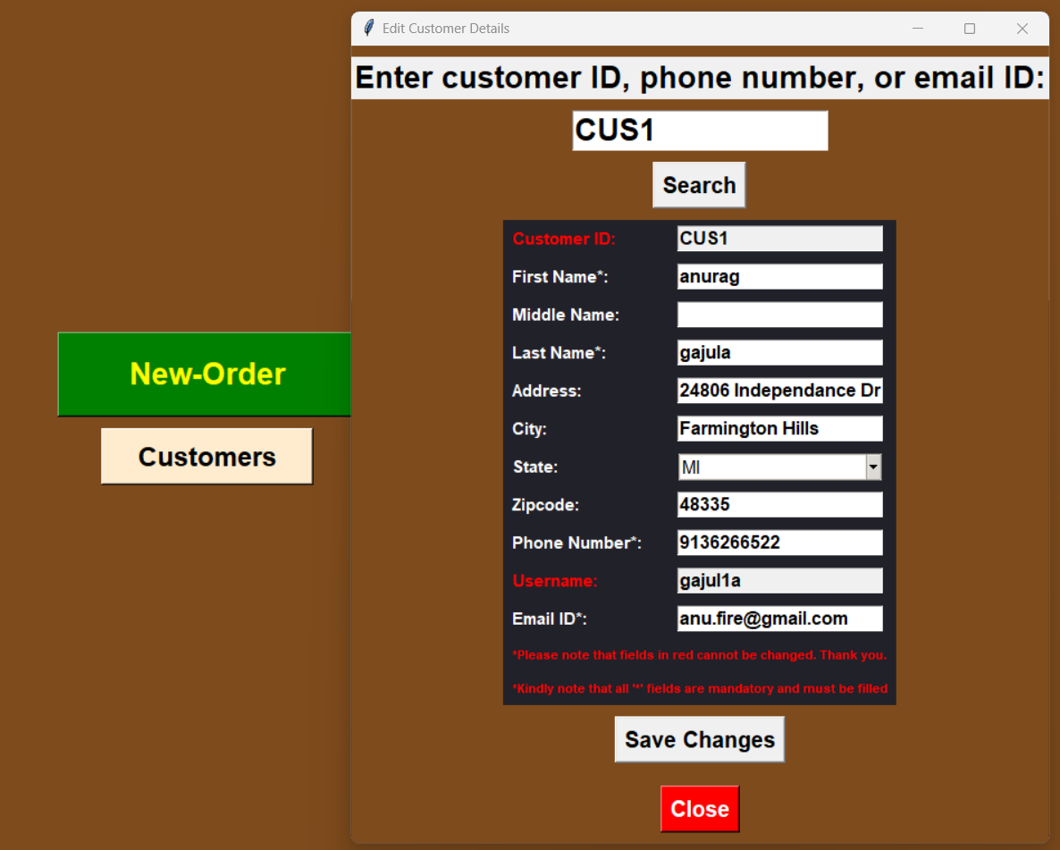

# **10. Employee New Order Screens**

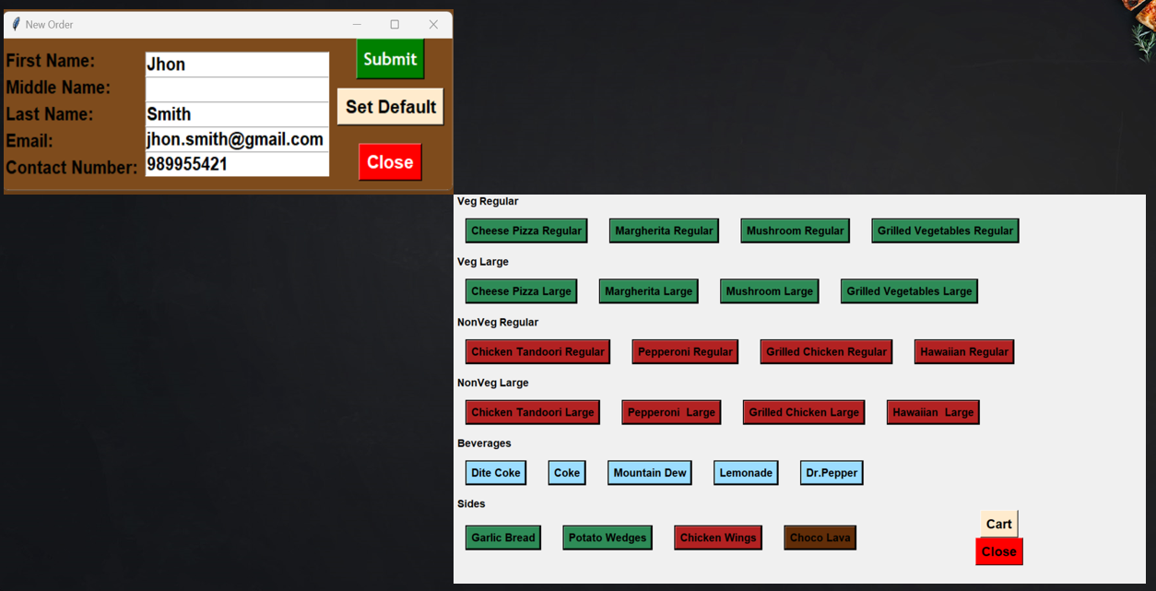

**\*\* Note : View Cart, Payment and Receipt Windows are same as shown above.**

# **11. Order Status**

**11.1 Pending**

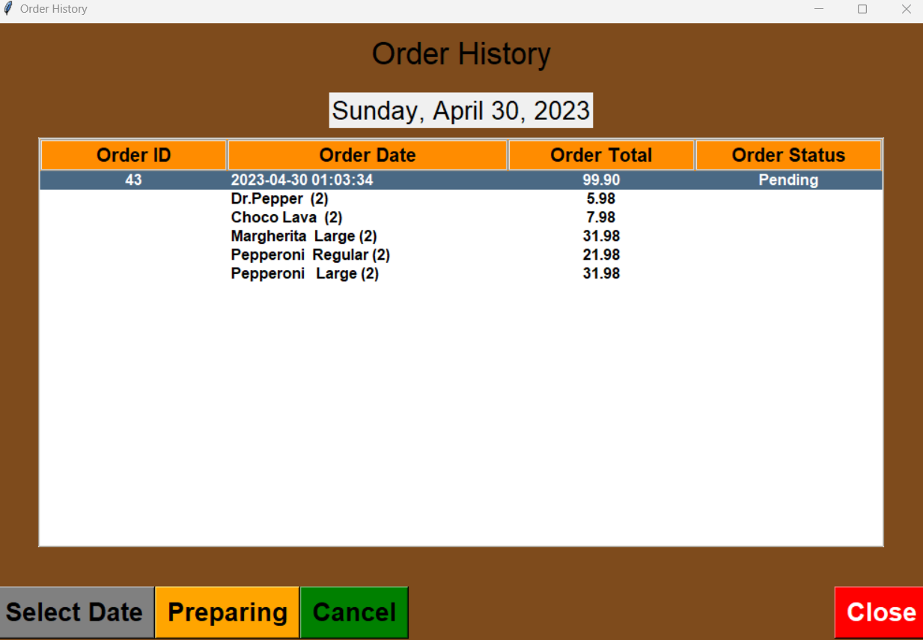

## **11.2 Preparing**

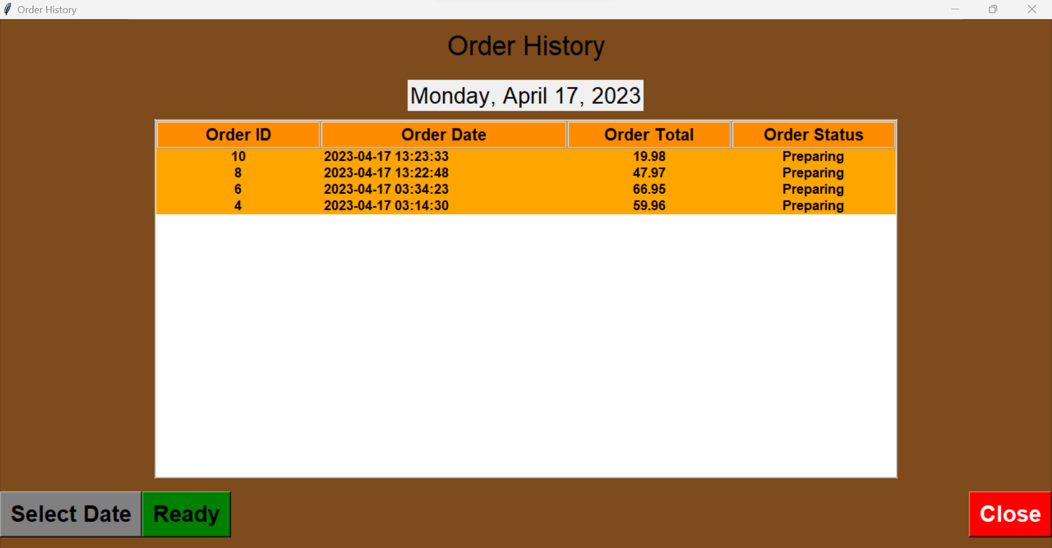

## **11.3 Ready**

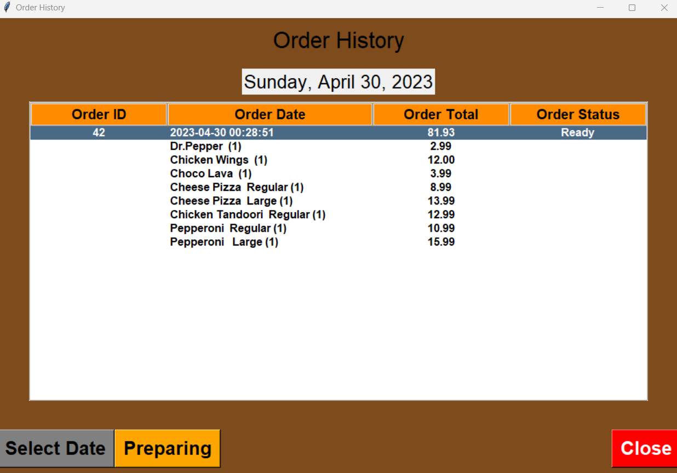

## **11.4 Cancelled**

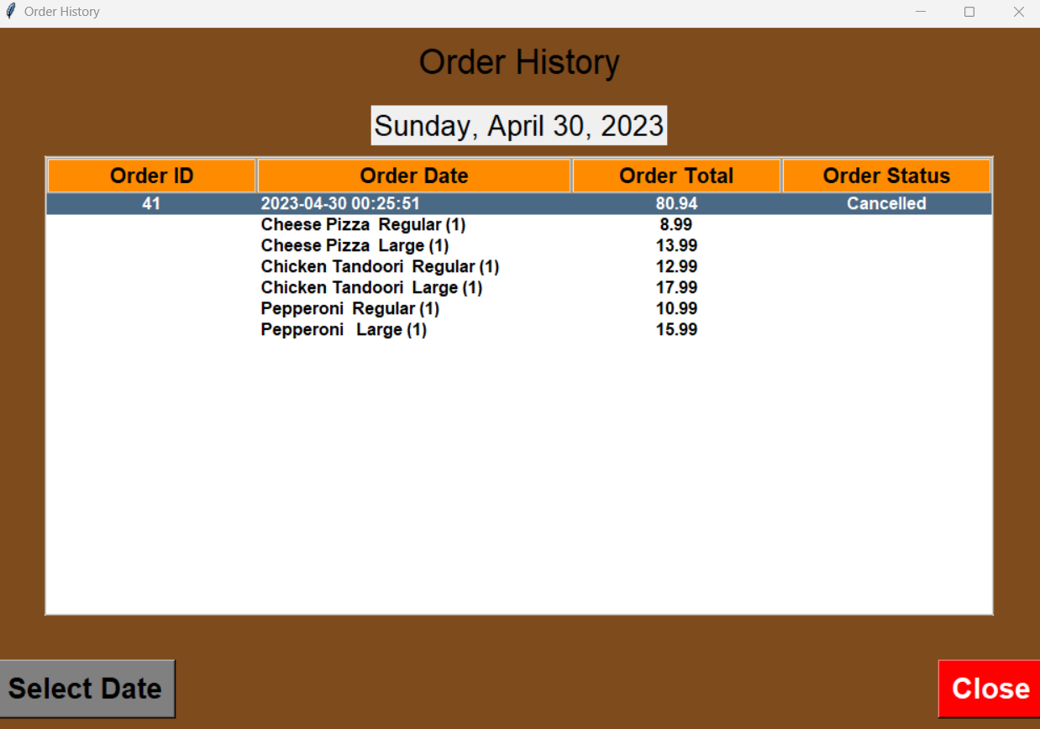

# **12. Reports**

## **12.1 Customers Table**

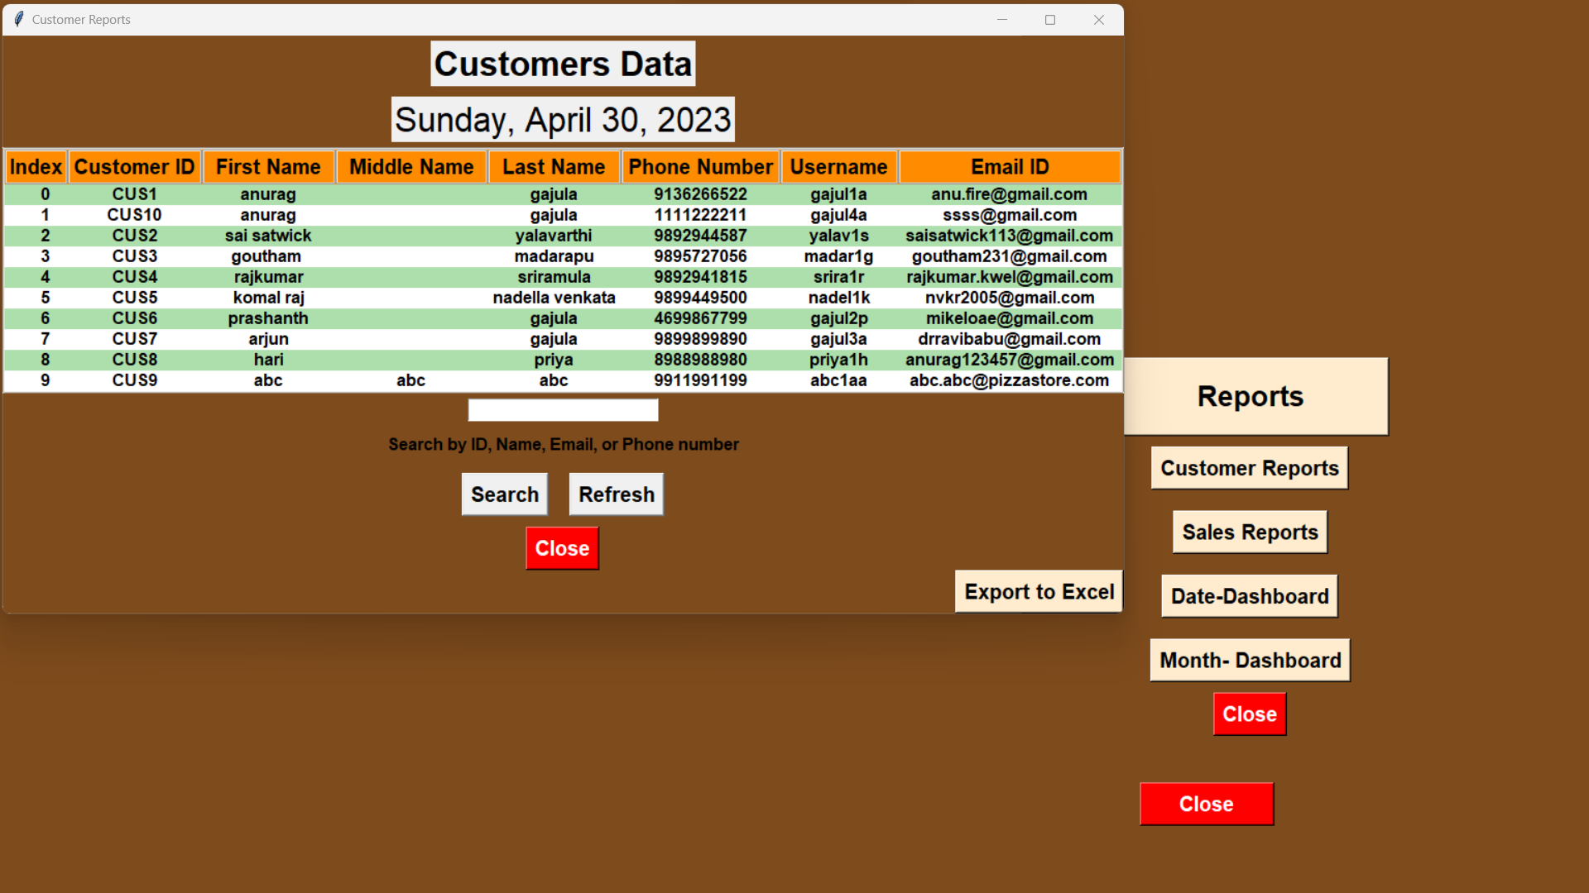

## **12.2 Sales Table**

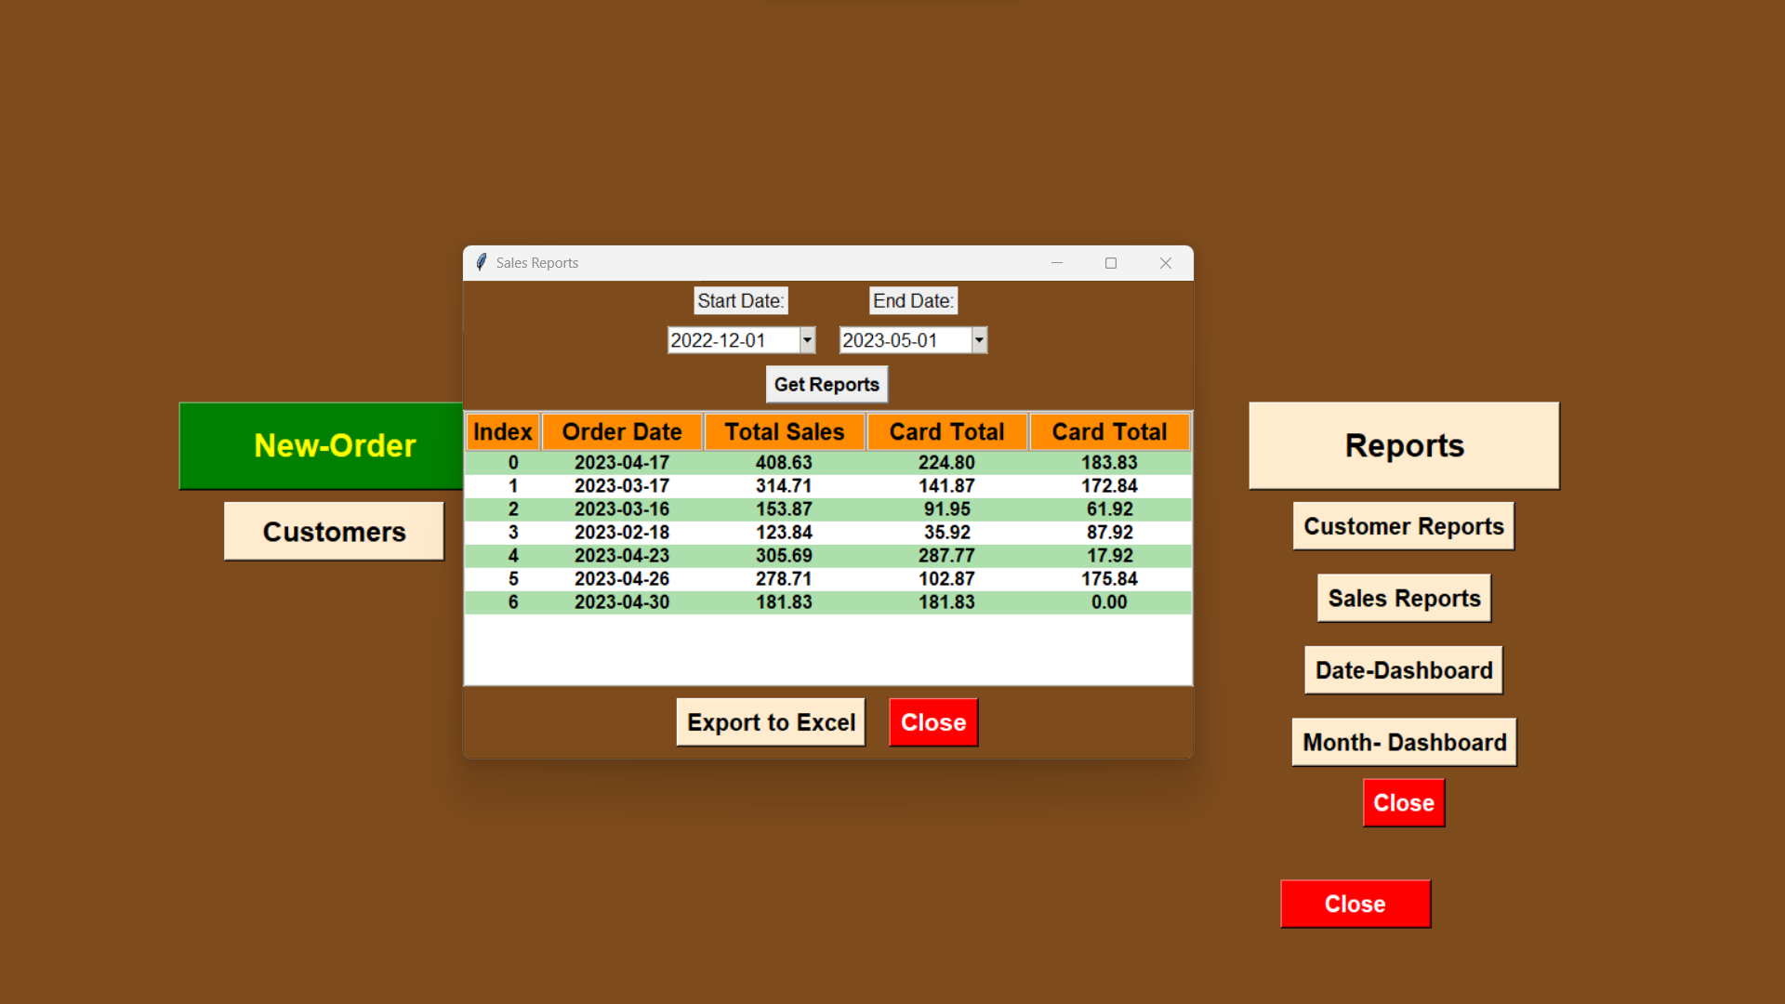

## **12.3 Dashboard**

